**Launching the Instance(Ec2) in Amazon**

Step1: Login the Aws console in following link

<https://signin.aws.amazon.com>

Step2: Click on the **Services** in console and select the **EC2** under the **Compute**

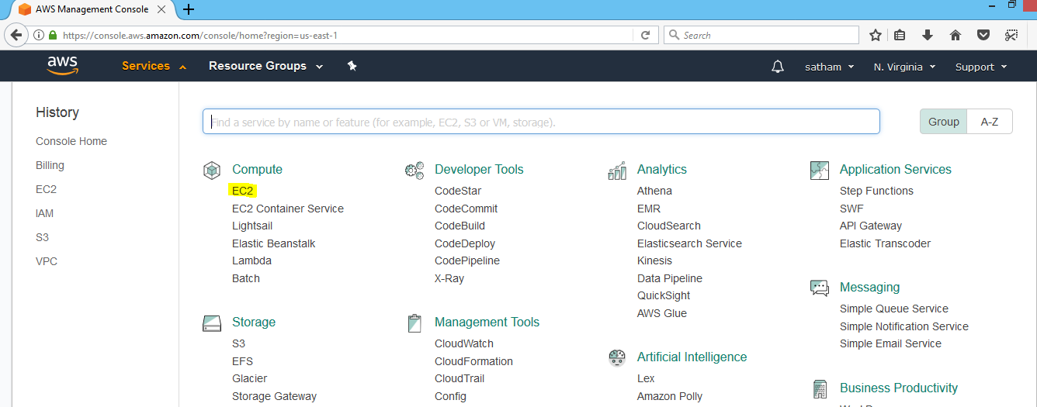

Step2: click on the on Launch Instance

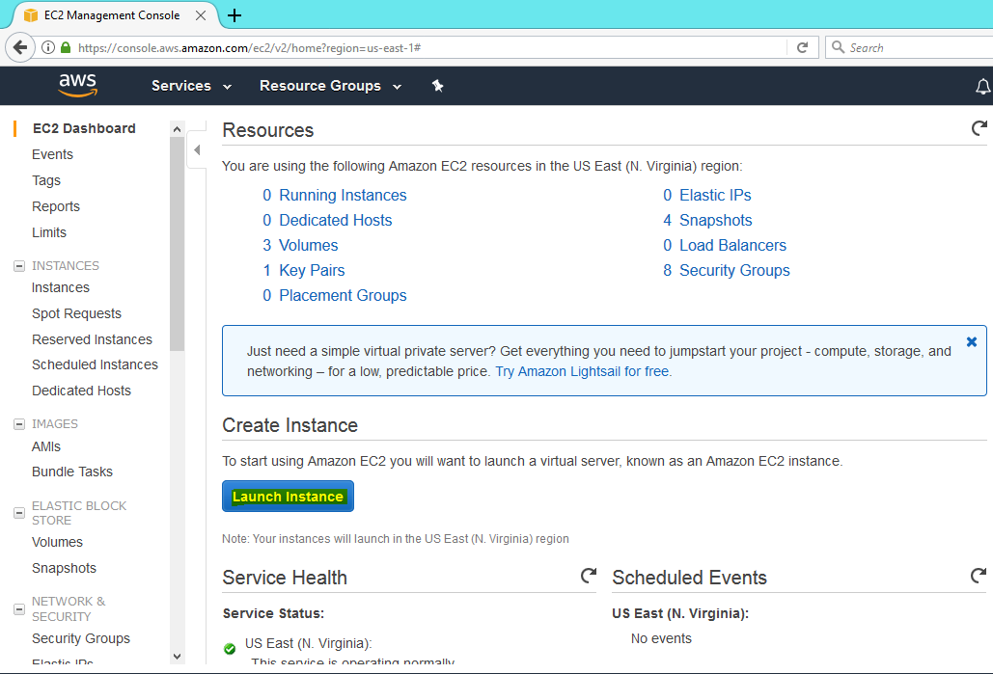

Step3: choose an amazon machine image(AMI) what you have to select

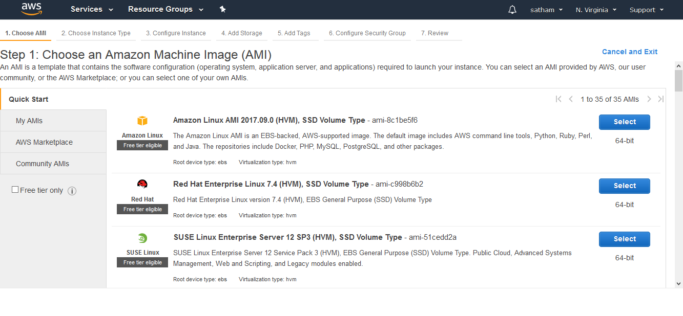

Step4: Choose the Instance type and select Next configure instance details

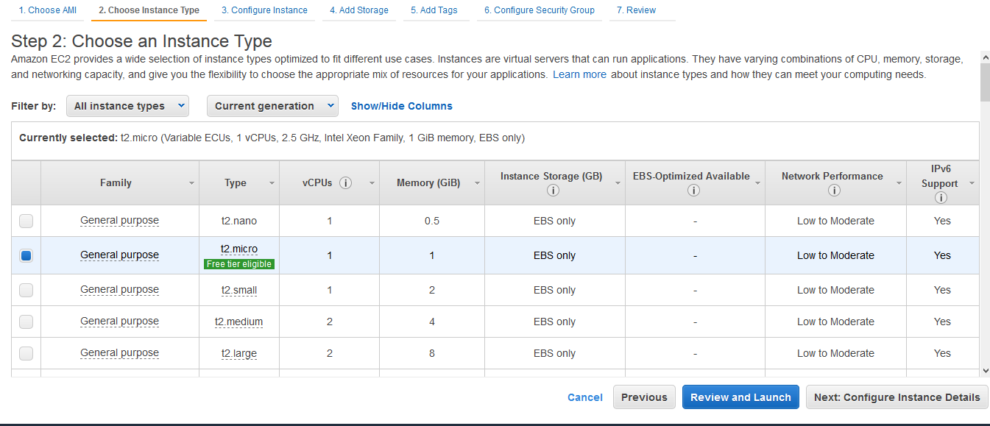

Step 5: configure instance details like no of instance, subnet,Network

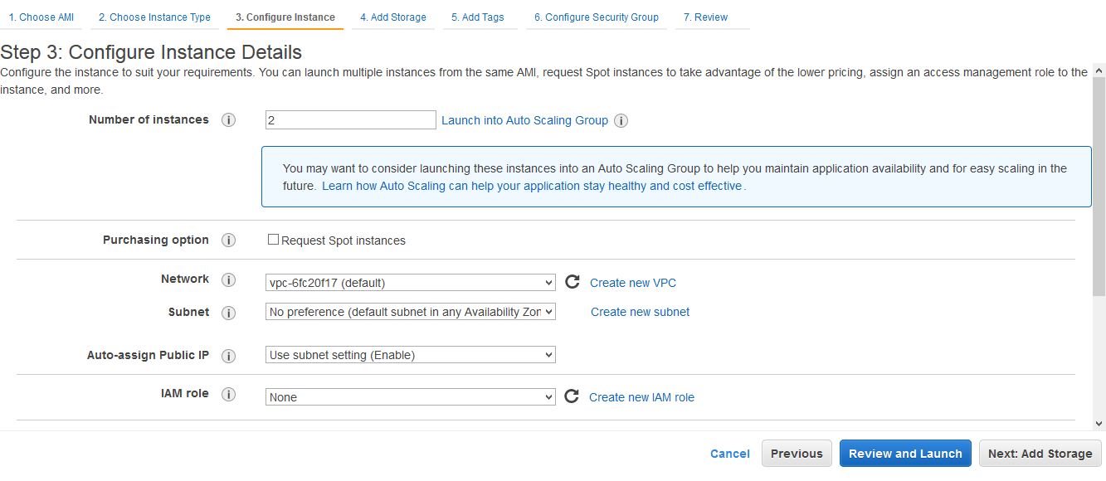

Step 6: after configuration details click on the Add Storage

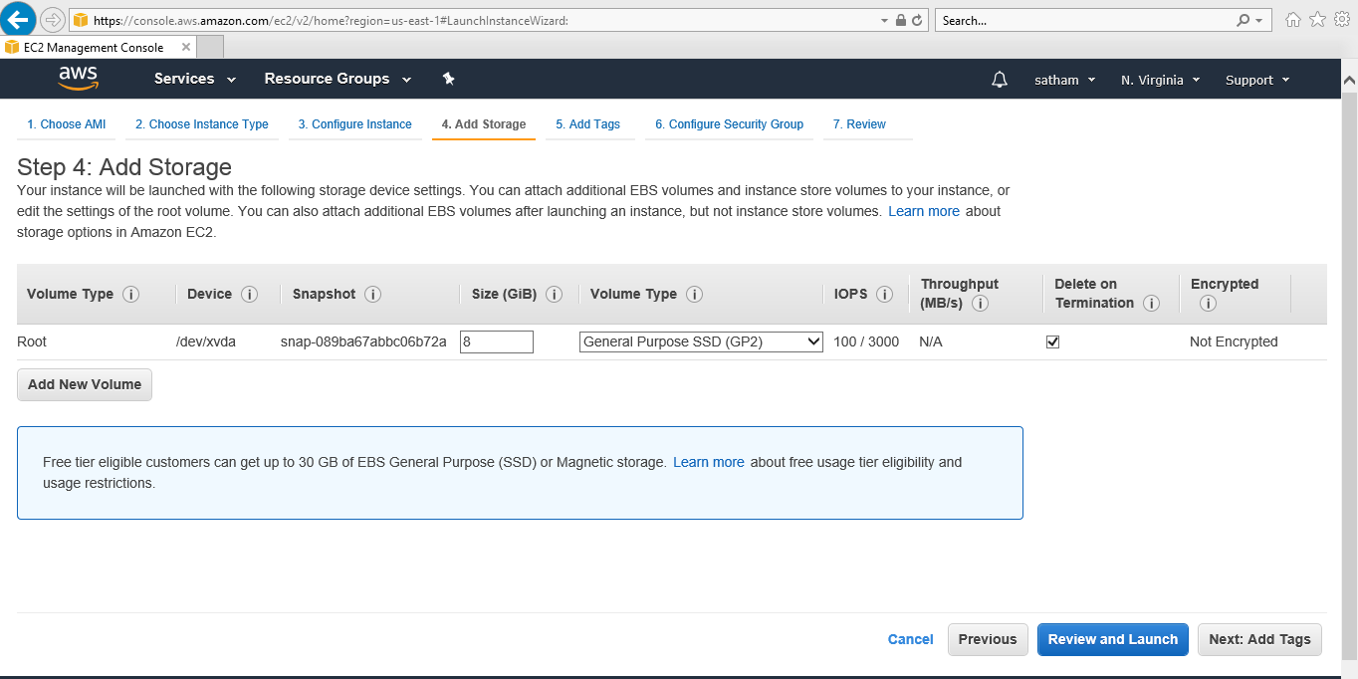

Step 7 : In this Add Store of Instance the default Size of server space in free case 8GB free tire eligible customers can get up to 30 GB of EBS General Purpose (SSD) or Magnetic storage, then click on Add Tags

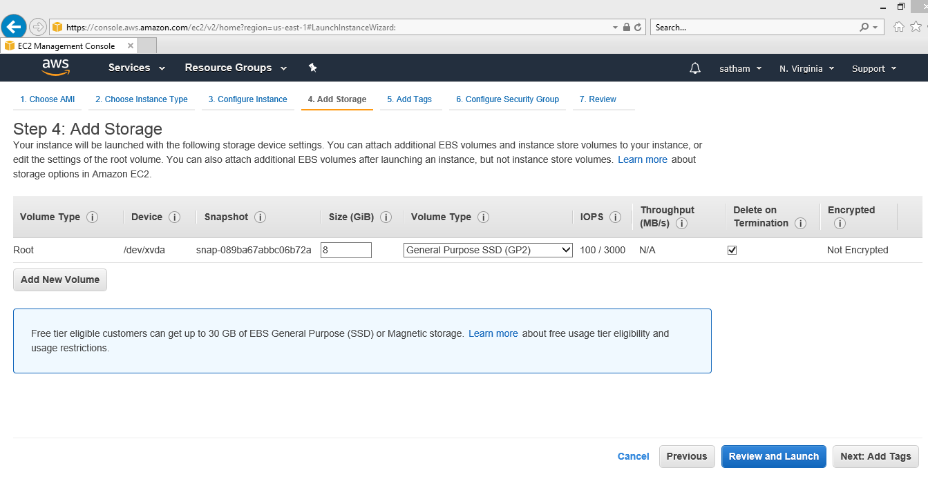

Step 8 : After volume added make Tags of Instance which you want to identify.

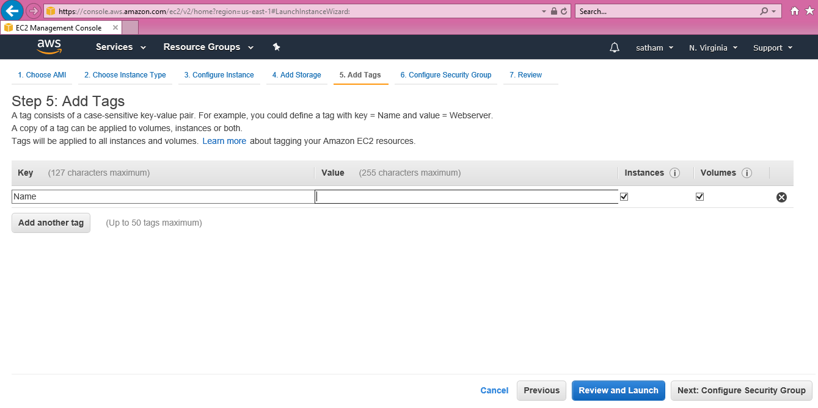

Step 9: In the Configuration Security if the instance has launch default it has selected Create New Security group or you can create New security group

Then select Review and Launch

